**IT24101024**

**PS Lab 05**

01. 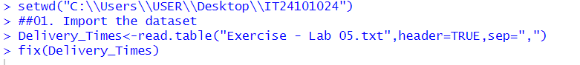

03. The distribution is roughly symmetric with a slight right skew. Most delivery times are between 35 and 55 minutes.

